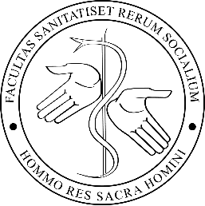
Trnava University in Trnava
Faculty of Health Care and Social Work/Department of Social Work

Academic year 2023/2024
Courses taught in English for Erasmus+ students

Course Code | English title of the course | Degree | Credits | Term | Details
XSPb018 | Social policy | Bachelor | 5 | Winter/1st  or  Summer/2nd
RDSRB34 | Social security | Bachelor | 6 | Winter/1st  or  Summer/2nd
RDSRB19 | Comprehensive rehabilitation | Bachelor | 5 | Winter/1st  or  Summer/2nd
RDSRB17 | Early intervention | Bachelor | 5 | Winter/1st  or  Summer/2nd
XRDSR016 | Social Pathology | Bachelor | 5 | Winter/1st  or  Summer/2nd
RDSRB21 | Family in Low-income Countries | Bachelor | 3 | Winter/1st  or  Summer/2nd
RDSRB41 | Assistance in inclusive education (Online course) | Bachelor | 3 | Winter/1st  or  Summer/2nd
SPB25 | Clients with mental disorders in context of social reality | Bachelor | 5 | Summer/2nd
RDSRB30 | Dying and Loss in Family | Bachelor | 3 | Summer/2nd
YSPm021 | Clinical Social Work | Master | 5 | Winter/1st
SPM18 | International Social Work and Multilevel governance | Master | 5 | Winter/1st  or  Summer/2nd
 |  | 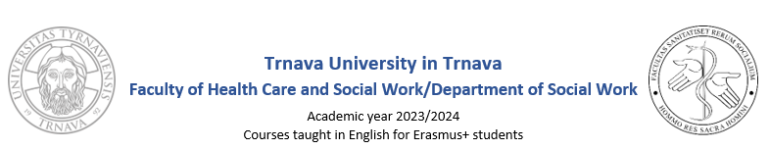
Course Code | English title of the course | Degree | Credits | Term | Details
YSPRm006 | The Social Economy | Master | 5 | Winter/1st  or  Summer/2nd
SPM16 | Psychohygiene and coping | Master | 5 | Winter/1st  or  Summer/2nd

