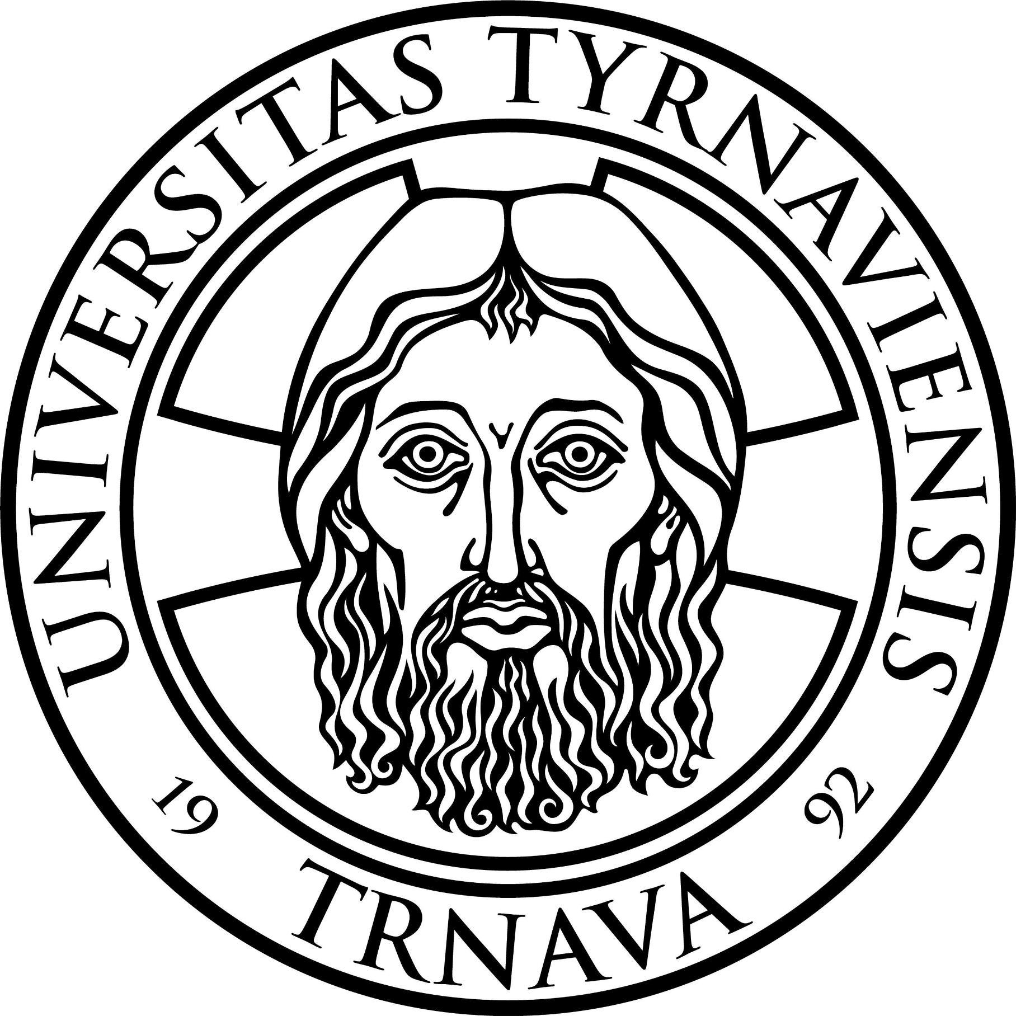  trnava  university  in Trnava |  | Erasmus+ Programme  Student mobility for study
EXCHANGE TO TRNAVA UNIVERSITY IN TRNAVA
(ACADEMIC YEAR 2017/2018)
INSTITUTIONAL INFORMATION
Full legal name of the institution: TRNAVA UNIVERSITY IN TRNAVA
Erasmus Code: SK TRNAVA01
Postal Address: Hornopotočná 23, 918 43 TRNAVA, Slovak Republic
Internet address: http://www.truni.sk
Head of the Institution: prof. doc. JUDr. Marek Šmid, PhD., rector
Phone: +421/33/59 39 203
Fax: +421/33/55 11 129
E-mail address: rektor@truni.sk
INTERNATIONAL RELATIONS OFFICE
ERASMUS+ OFFICE
Erasmus Institutional Coordinator  Phone: +421/33/59 39 214  Email: simon.marincak@truni.sk,zahranod@truni.sk | doc. ThDr. PaedDr Šimon Marinčák, PhD.  Vice-rector for International Relations
Coordinator Responsible for Outgoing students  Phone: +421/33/59 39 207  Email: marta.seckarova@truni.sk, zahranod@truni.sk  Room No. 209 | Ing. Marta Sečkárová  Erasmus+ Coordinator
Coordinator responsible for Incoming students  Phone: +421/33/59 39 207  Email: eva.filipova@truni.sk, zahranod@truni.sk  Room No. 209 | Ing. Eva Filipová  International Relations Officer
APPLICATION DEADLINES
- 30 June for Autumn Semester or Academic Year arrivals
- 30 November for Spring Semester arrivals

Nominations should be received before 15th of May and 15th of November to e-mail address: eva.filipova@truni.sk and include family and given name, gender, e-mail address, subject area of studies and period of mobility.

For instructions on how to apply after the nomination by home institutions,
please refer to
http://www.truni.sk/en/application-process

After the nomination by home institution, all necessary information abour application process will be sent by e-mail directly to Erasmus+ incoming students.

Completed Application package (Application form, Learning Agreement, Accommodation form) must be scanned and sent by e-mail: eva.filipova@truni.sk

WINTER TERM
Winter semester: 25/09/2017 – 15/12/2017
Examination Period of Winter Term: 16/12/2017 – 10/02/2018
SUMMER TERM
Summer semester: 12/02/2018 – 12/05/2018
Examination Period of Summer Term: 14/05/2018 – 30/06/2018
Eastern Holiday: 28/03/2018 – 03/04/2018
Summer Holiday: 01/07/2018 – 31/08/2018
1 September | Constitution Day **
15 September | Virgin Mary **
12 October | VENI SANCTE (The ceremonial Holy Mass for opening of the new academic year)*
1 November | All Saints Day **
17 November | Day of Struggle for Freedom and Democracy**
24 December | Christmas Eve **
31 December | New Year´s Eve **
1 January | New Year´s Day **
6 January | Epiphany **
1 May | Labour Day **
3 May | TE DEUM (The ceremonial Holy Mass for ending the academic year)*
8 May | Victory over Fascism **
5 July | St. Cyrilus and Methodus Day **
29 August | Slovak National Uprising **
*university days
**national holidays

NB: Please note, each faculty of Trnava university has its own academic calendar. You have to check the dates of the university academic calendar with the academic calendar of the faculty to come for a study in a regular time.

