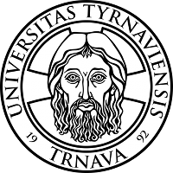

ECTS Grading Scale

In Slovakia the grading system is compatible with ECTS grading scale.

ECTS Grade | Slovak grading scale | Percentage of grading scale | Definition
A  B  C  D  E  FX | 1  1,5  2  2,5  3  4 | Max 100% - Min 91%  Max 90% - Min 81 %  Max 80% - Min 71%  Max 70% - Min 61%  Max 60% - Min 51%  Max 50% - Min 0% | EXCELLENT – outstanding performance with onlz minor errors  VERY GOOD – above the average standard but with some errors  GOOD – generally sound work with a number of notable errors  SATISFACTORY – fair but with significant shortcomings  SUFFICIENT – performance meets the minimum criteria  FAIL - some more work required before the credit can be awarded

ECTS credits:

1 full academic year = 60 credits
1 semester = 30 credits
1 term/trimester = 20 credits

